Love’s Summer Reading Challenge 2017
*Seventh Grade going into Eighth Grade: Bring this to Mrs. Love’s class at the beginning of the 2017-2018 School Year for a prize.*
*Eighth Grade students going to high school: send this to me in an email or post on the blog and I’ll let your high school teacher know.
Post your thoughts on the Reading Road Trip blog.
*No, I don’t know what the prize will be.
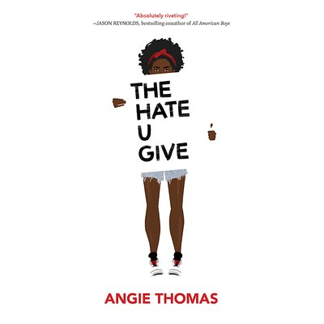 | 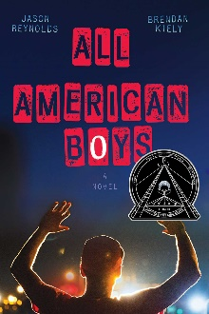 | 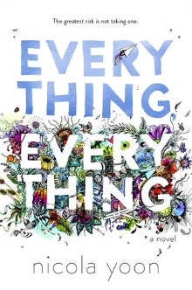
 | 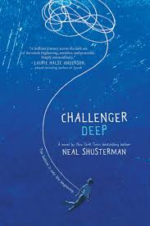
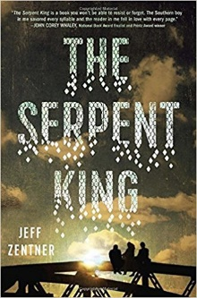 | 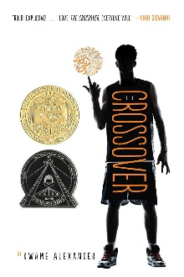 | Choice  Put a novel or graphic novel of your choice. Another recommendation: read a classic – Charles Dickens, JK Rowling, Steinbeck, etc.

